Health and Physical Education
Grade 1 Personal Fitness Study Guide
P.E. Standard: 10.4.3.C Explain and identify changes of body responses to changes in physical activity.
10.1.3.B Identify and know the location and function of the major body organs and systems.

DIRECTIONS: Please review the following information with your child for our
5 point Health and Physical Education quiz next week.

ALL STUDENTS SHOULD UNDERSTAND:

- Muscles make your body to move.

- The skeleton/bones support and protect your body.

- Running, biking and playing cause your heart to beat faster.

- You should be physically active for at least 60 minutes a day.

- The more you move the harder your heart and lungs work.

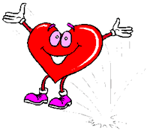
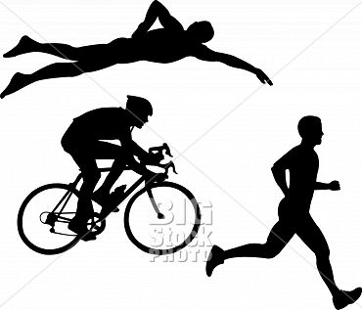

SEVEN DAYS WITHOUT EXERCISE MAKES ONE WEAK!

